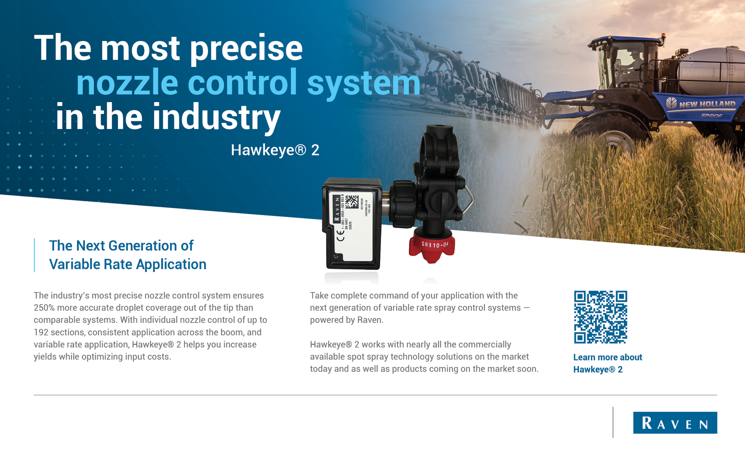

www.dealerwebsite.com

Dealer Name

Address

(XXX) XXX-XXXX